Covid-19 pathway to recover Environment

Ounam Gupta

# Abstract

The pandemic has casted a different world which was unimaginable with such difficult times. Even though the pandemic brought such life threatening situations, there were some positive implications to the environment which were observed from the halt in day to day activities of the human race.

# Defining Period

This report manifests over such allegations to discover how the pandemic has healed the nature and what has made such an impact and thereafter discussing some solutions and projectiles. Moreover, one of the most crucial questions to start with is to discover **if the pandemic has reversed the worsening conditions on Earth, or was the time not sufficient enough to notice something significant?** The Covid 19 virus was declared a pandemic on March 11, 2020 and India immediately went under a lockdown on March 23, 2020 which was carried till the month of May.

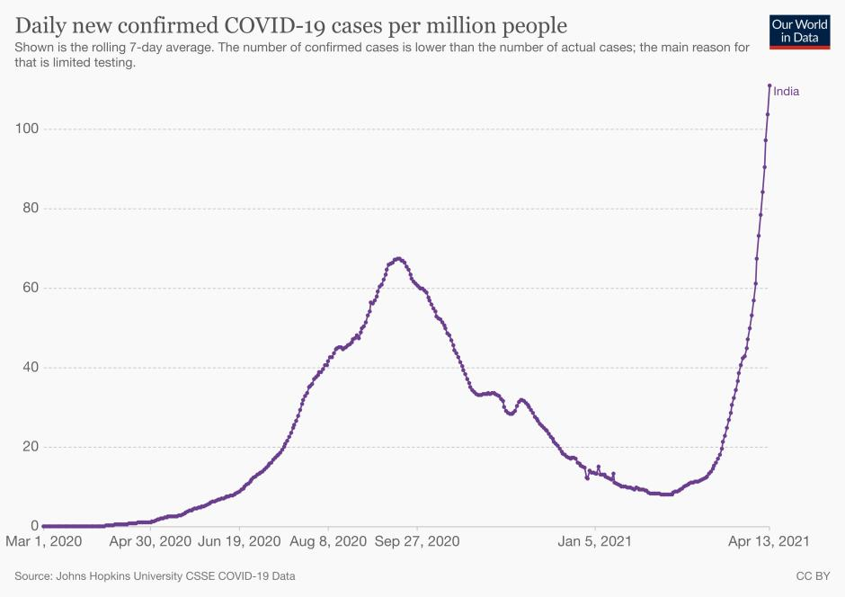

Lockdown

Unlock - 1.0

Unlock - 2.0

Unlock - 3.0

Unlock - 4.0

Unlock - 5.0

Unlock - 6.0

Lockdown

(Lalwani, 2021) (Wikipedia contributors, 2021)

The graph rose significantly during June, 2020 to January, 2021 but the lockdown phases were strictly imposed only before the first wave. After May, 2020, the lockdowns were lenient and many of the services were resumed to recover the soaring economy. The Petrol import dipped to a record low in March, whereas even during the first wave of Covid 19 and lockdowns saw a normal consumption of petrol. This indicates that the transportation resumed with social activities resuming more than ever.

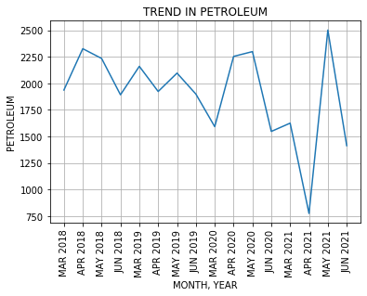

Trends in petrol consumption

This indicates that a significant difference from a normal day would only be visible during the March-May period. Thus, any further lockdown would not depict a positive attribute for the climate to be affected.

# Defining Region

There are innumerable crucial environmental factors that are to be considered while analysing for the changes, this report discusses over one concern which has outweighed the distress of Novel Corona Virus, i.e., Air Quality of the capital city of India, Delhi. NOTE:- This does not disregard the poor (dead) water quality which is deemed to be one of the poorest and unsafe water in the country (Correspondent, 2019) and several other hazardous factors that lie in the city.

# Exploring

The poor Air quality is mainly from the industrial and transport sector, but a significant correlation exists with the unorthodox practices of the farmers of Haryana and Ludhiana which has been a critical aspect of the over pollution in the Capital city. What may suggest that? The Air quality of Delhi remains toxic throughout the year but a sudden spike that makes the air Delhites breathe hazardous air which happens, is specifically around the months of October and March. This has been closely related to the fact that Farmers around these particular months tend to burn their crops to make way for next crop in the influence of a Water act imposed by the Government to protect ground water {Sub soil Water Act 2009 – Prohibiting nursery sowing and transplanting paddy until May 15 and June 15 (Mohanty, 2020)}.

[](GIFs/air2019delhi.gif)PM 2.5

The PM 2.5 concentration remains high throughout the year with few spikes in some of the months.

Noticeable spikes:

* March, May, July, October

Note: Please press Ctrl + Mouse click to view the GIF content.

The plot visualises the fire in regions of Punjab in April of 2018, 2019 and 2020. It can be observed that field fires were cut short due to limitations on movement and even farming was suspended. The intensity of fire (in mW defined by the size of circle) shows that mostly fire was small scale (MCD14DL, 2020) and comparatively very lesser in number.

# C:\Users\user\AppData\Local\Microsoft\Windows\INetCache\Content.Word\fireplot.jpg

Fire and thermal anomalies in April

# Connecting Dots

But how the fires impact the atmosphere of Delhi, is explained by the visualisation below which shows the slow wind movement from North (Ludhiana) to centre (Delhi) where the wind becomes too slow after arriving in Delhi. The smoke spikes the AQI, which is already on toxic levels and thus stating that fires on farms and fields are one of the major contributors to the poor air quality.

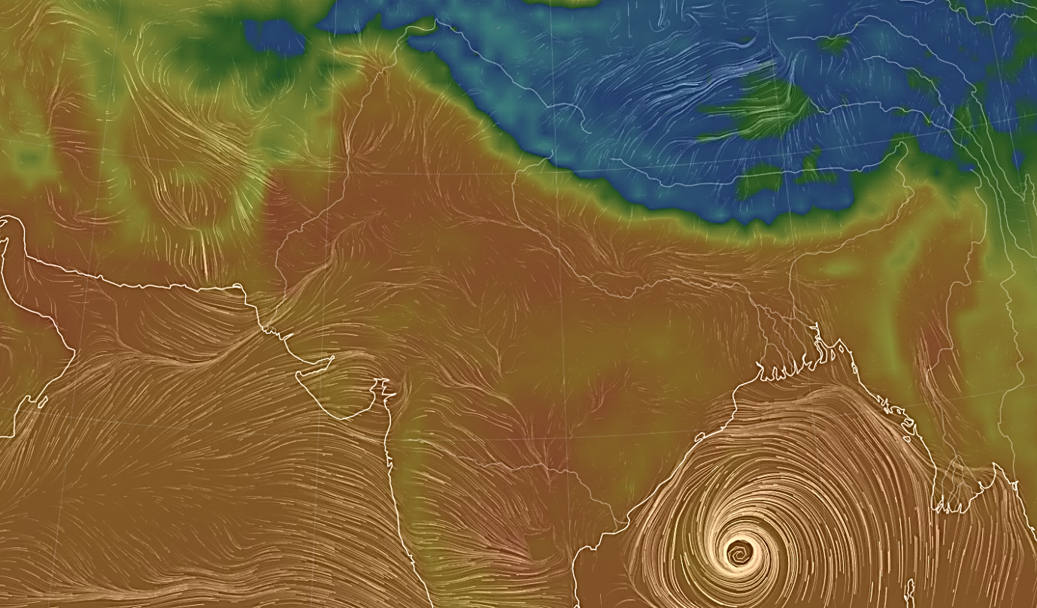

Wind movement in the month of March (*Earth :: A Global Map of Wind, Weather, and Ocean Conditions*, 2020)

# Analysis

The plots are GIF formats and analysing them illustrates that many of the harmful gases were seemed to be controlled in the period of March to May of 2020 in comparison to the year 2018 and 2019. The significant difference is varying with different dates and type of gas. Therefore it was challenging to portray a dynamic data in picture format.

Note: Please find attached GIF files to check Comparative data of each gas in different months.

Carbon Monoxide

CO April GIF

CO May GIF

CO March GIF



Sulphur Dioxide

SO2 April GIF

SO2 May GIF

SO2 March GIF



Aerosol at 550nm

April GIF

May GIF

March GIF



In further investigation to see if there exists a correlation between Fire and AQI, I have developed a correlation matrix to see if variables interact with each other. But the data had no linear relation between them and therefore, the matrix is termed as False projection of data. The plots are to display that data between the two do not bind together.

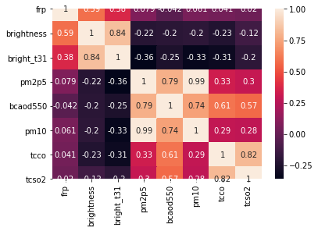

Correlation matrix between fire and air quality

# Positive Indications

“Ozone levels pose high health risk in Delhi” (Ozone Levels Increase in Delhi, Pose Health Risk, 2020), the increase in Ozone went to its highest in 2018 in April from the rising Nitrogen, CO and various other gases that get exposed by sunlight. But it can be noted in the month of March and April of 2020, with the control in such gases, ozone was recovering and which shows that a mere rest of 2 months can positively heal the environment if it would have been stretched for a few more months.

This is a projection if conditions like March-May would not have happened, the fire index would have been estimated to be lower in next few months.

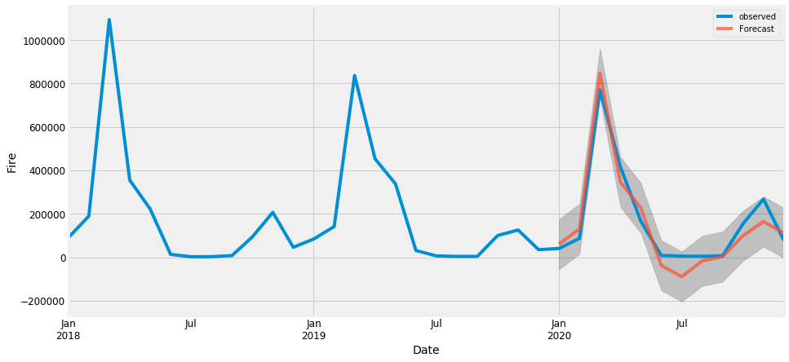

# Known Solution

Even though fire and transportation have been analysed and are identified as the major attributes in the depletion of air quality. This basic knowledge of health hazards from such air is known to every individual facing the harsh environmental conditions but they are not aware of the controlling parameters. Moreover, it is nearly impossible for civilians to shift to an alternate pathway easily as it involves a mass number of population to take any step. Government mandates several ideologies to a better future but these are the hard routes. In such a case, enforcement of stricter laws to safeguard environment with basic awareness about the situation is required. The focus has been put on this matter is to bring attention to the locals and the general population to make them aware of the reality. Often times, such facts are un-popularised due to government control over media and thus, it must be promoted to bring a notion of change. Such basic information is often missed. The report briefly describes the true aspects of air pollution with significant justification to take the necessary steps before it becomes too hard to recover.

# Solution Proposal

The field fires are a political issue which needs to be addressed by high order justice courts to find potential measures to a cleaner route for the farmers.

With the commencement of EV Buses by Tata group for public transport, a cleaner fuel can be the way out from petrol or diesel buses. It will require a well-established network of EV charging station with cheaper electric vehicles to promote it’s usage.

# Areas to Improve

The report is minimal and the approach is narrow to cover such a vast topic. Many divisions have been overlooked due to insufficiency of data or memory power to process the data in this time frame. With enough time, a deeper analysis of several other factors such as locating factories by the area and observing their pollution emission to analyse which factories operate under the legal criteria. Further, rooting the control parameters for over polluting industries and establish a map of such failing industries. This can be done by checking pollution index in these industries, analysing the wind direction and how they potentially pollute the residential areas.

# A word for Hiring team

The work undergone in this report is limited to the time and prior knowledge in this field but I am very enthusiastic about the environmental concerns. And I see this technical job profile as an opportunity to join one of the major upcoming climate tech companies. All of this work has been completed within 3-4 days in which I learnt about the climate data analysis and much more technical aspects that undergo with monitoring the climate. The challenge was to acquire this type of data, and then understand and utilise it. It was very exciting to learn about the processes that undergo in analysing geospatial data and it made me realise the actual process that is involved in maintaining and using such type of data.

I have used different approaches to handle and visualise data to see what all things are possible. Many of the visuals are in GIF format which are attached in the ZIP folder.

Timing was the biggest constraint while working on this project as it is so massive and requires so much of analysis and figuring out various angles to look for.

“I look forward to work and learn more about our environment and the technology that works behind it to make it all possible.”

# References:

1. M.C.D.D.L. (2021, April 30). MCD14DL | Earthdata. Earth Data. https://earthdata.nasa.gov/earth-observation-data/near-real-time/firms/c6-mcd14dl
2. Wikipedia contributors. (2021, August 9). COVID-19 lockdown in India. Wikipedia. <https://en.wikipedia.org/wiki/COVID-19_lockdown_in_India>
3. Lalwani, V. (2021, April 16). India’s second Covid-19 may be impacting more youth and kids. Quartz. <https://qz.com/india/1997559/indias-second-covid-19-may-be-impacting-more-youth-and-kids/>
4. Mohanty, P. (2020, October 26). Rebooting Economy 40: Why Punjab farmers burn stubble? Business Today. <https://www.businesstoday.in/opinion/columns/story/indian-economy-agriculture-why-punjab-farmers-burn-stubble-crop-residue-paddy-burning-276782-2020-10-26>
5. Correspondent, S. (2019, November 16). Delhi has the most unsafe tap water. The Hindu. <https://www.thehindu.com/news/national/only-mumbai-meets-drinking-water-quality-standards/article29992150.ece>
6. earth :: a global map of wind, weather, and ocean conditions. (2020). Earth.Nullschool. <https://earth.nullschool.net/#2020/05/18/2100Z/wind/surface/level/overlay=temp/patterson=75.28,26.77,2052/loc=53.206,12.232>
7. Ozone levels increase in Delhi, pose health risk. (2020). Downtoearth. <https://www.downtoearth.org.in/news/air/ozone-levels-increase-in-delhi-pose-health-risk-63964#:%7E:text=Published%3A%20Friday%2012%20April%202019,health%20risk%20in%20the%20Capital.&text=This%20year%2C%2038%20per%20cent,up%20to%2061%20per%20cent>

# Bibliography:

1. ECMWF Reanalysis v5. (2021, June 4). ECMWF. <https://www.ecmwf.int/en/forecasts/dataset/ecmwf-reanalysis-v5>
2. Latitude and Longitude Finder on Map Get Coordinates. (2021). Lat Long Finder. <https://www.latlong.net/>
3. Air during COVID-19 lockdown: March’s last week cleanest so far in Delhi. (2020). DownToEarth. <https://www.downtoearth.org.in/news/air/air-during-covid-19-lockdown-march-s-last-week-cleanest-so-far-in-delhi-70193>
4. TRADING ECONOMICS. (n.d.). India Imports of Crude Oil | 2014–2021 Data | 2022–2023 Forecast | Historical | Chart. Retrieved August 10, 2021, from <https://tradingeconomics.com/india/imports-of-crude-oil#:%7E:text=Imports%20of%20Crude%20Oil%20in%20India%20averaged%2017.55%20TONNE%20Million,Million%20in%20July%20of%202020.&text=India%20Imports%20of%20Crude%20Oil%20%2D%20values%2C%20historical%20data%20and%20charts,updated%20on%20August%20of%202021>.

# Data Sources:

1. Data | Copernicus. (n.d.). Atmospheric Data Center. Retrieved August 10, 2021, from https://atmosphere.copernicus.eu/data
2. Copernicus Climate Data Store | Copernicus Climate Data Store. (n.d.). Copernicus. Retrieved August 10, 2021, from <https://cds.climate.copernicus.eu/cdsapp#!/home>
3. https://firms.modaps.eosdis.nasa.gov/country/

Submitted By:

Ounam Gupta

Monash University